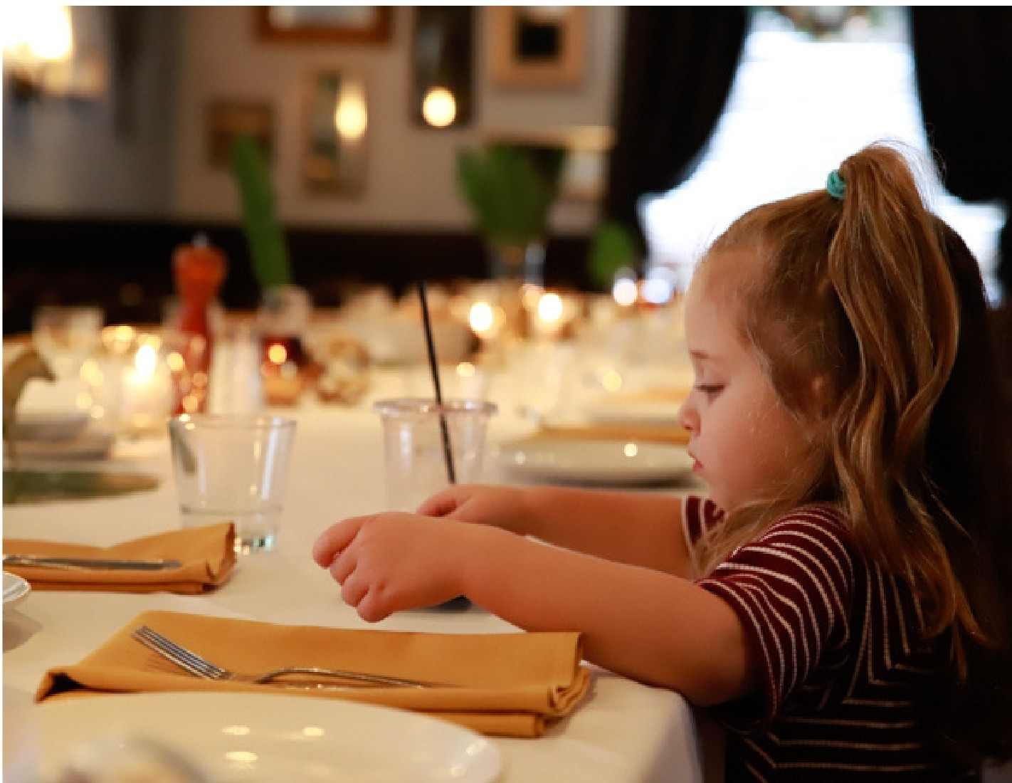
ITALIAN INSPIRED KITCHEN + BAR

+

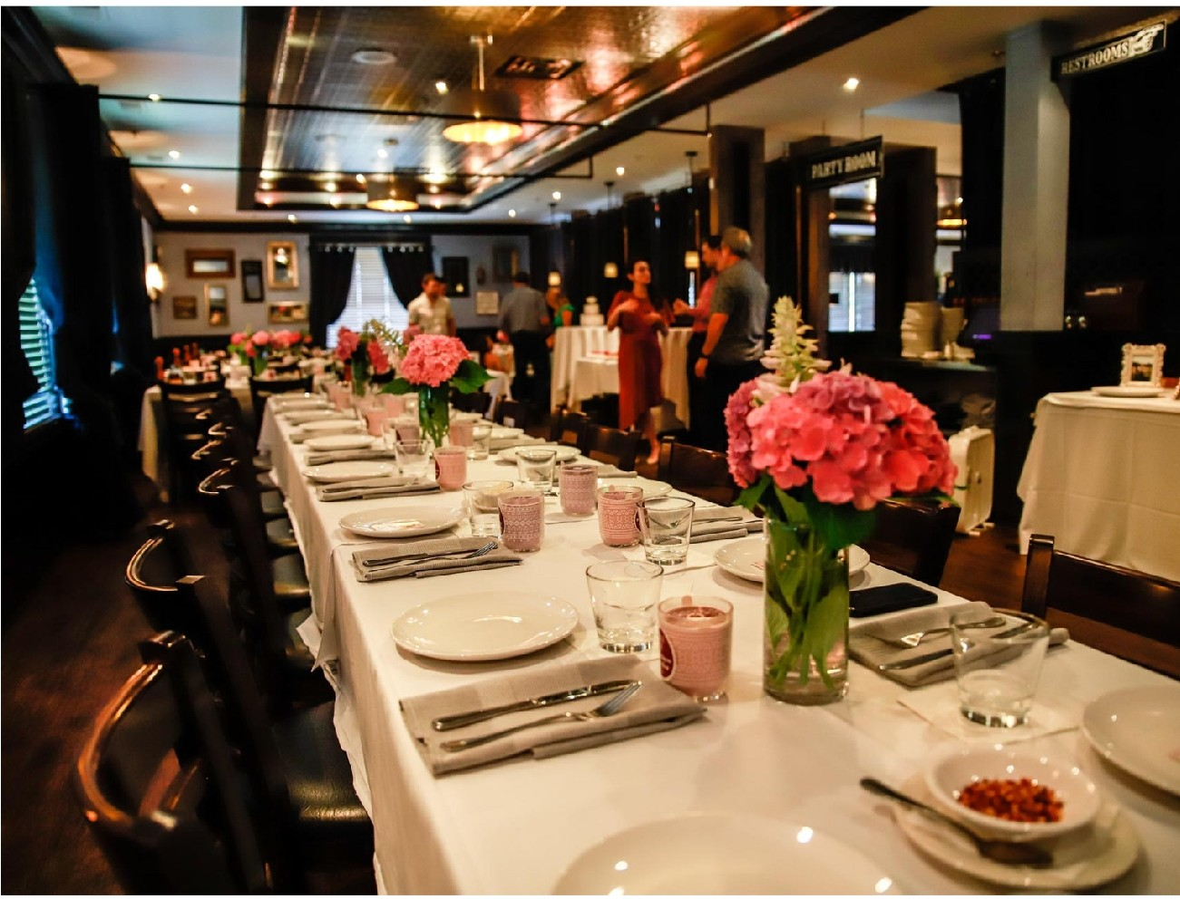
www.vaisnaperville.com

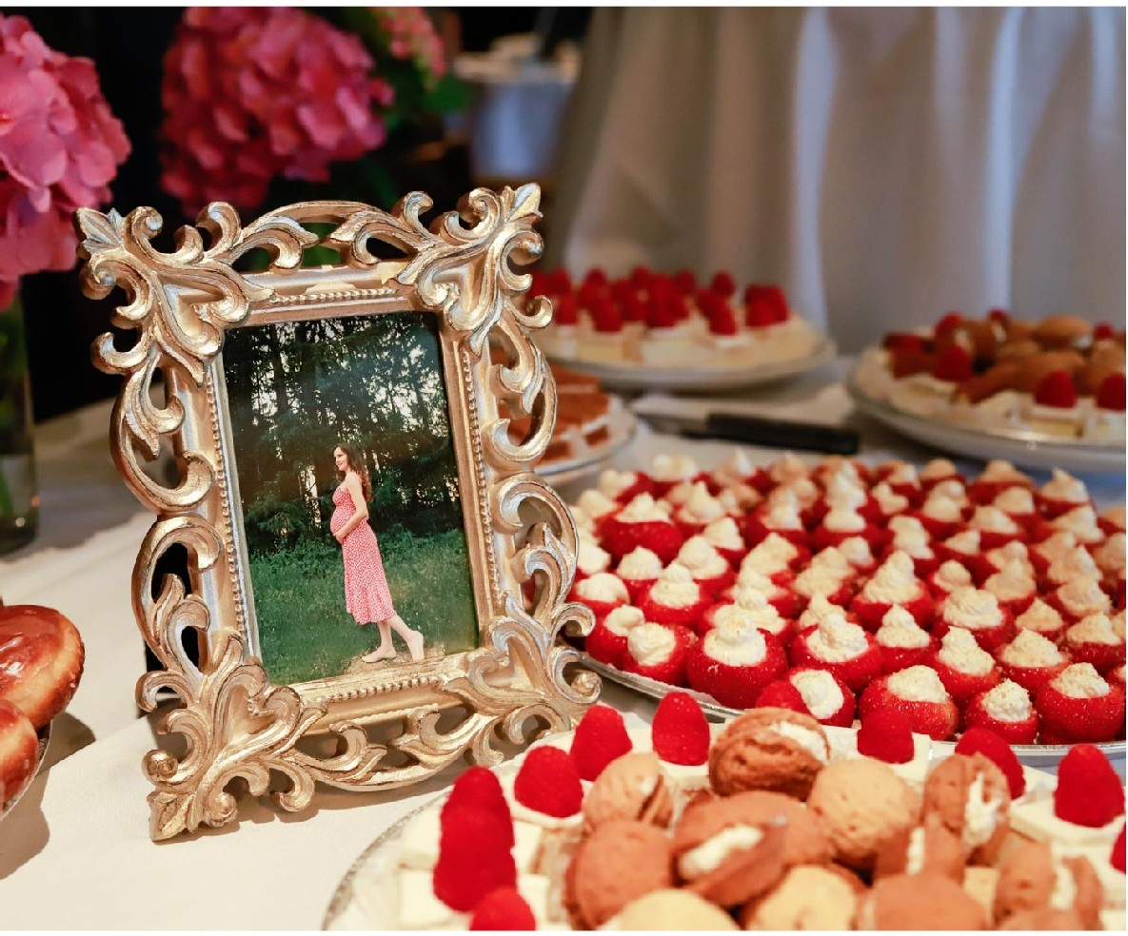
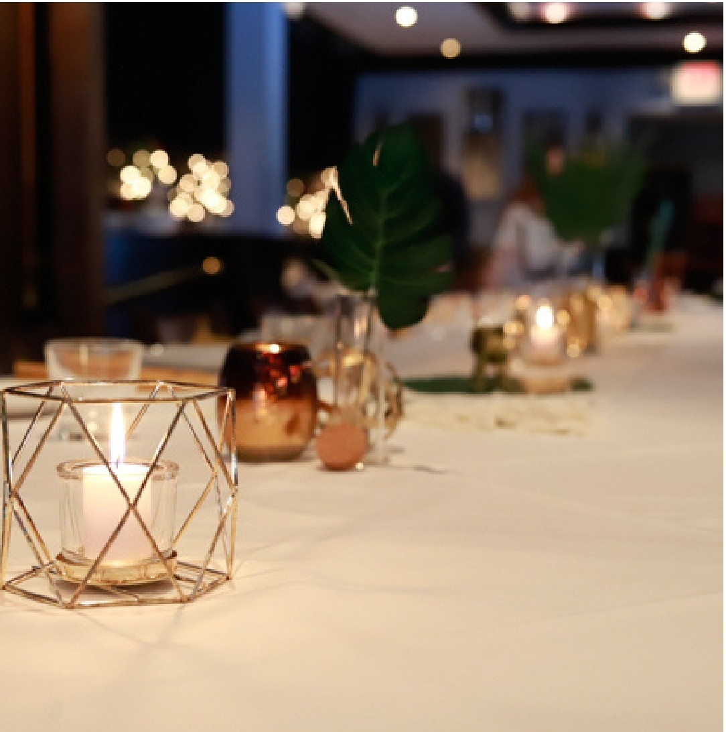

GUARANTEED GUEST
COUNT
MENU SELECTIONS
A guarantee of the final number of guests is required 3 business days prior to the event. If the patron does not confirm the guest count, then the original number of guests, as specified on the Special Event Agreement, will be utilized as the guaranteed number or actual number, whichever is greater.

ROOM MINIMUMS
Private dining spaces may be assigned a minimum of food and beverage based on the day of the week and
the time of the event. The minimum represents the dollar amount that must be spent to secure the room privately.
If the room minimum is not met, an additional “room” charge will be added to the final bill. Sales tax and service charge do not contribute to the minimum food and beverage requirement.

DEPOSITS & PAYMENTS
VAI's may require a deposit when booking a group dining reservation. Payment of the deposit, along with a fully executed Special Event Agreement signed
by both patron and Event Sales Manager, are required to confirm the event. Deposits will be deducted from the final guest check
and the customer will be responsible for payment of
the remaining balance on the night of the event. Sales tax, service charges, rentals and room fees do not contribute to food and beverage minimums. Final payments to be made by cash or check. Gift cards not accepted for private events. Credit Card payments will have a 3% processing fee added to the final bill.

TAXES, SERVICE FEES & GRATUITIES
Local taxes will be applied to the subtotal at the applicable rate on the day of the event function. In lieu of a gratuity,
VAI’s adds a 23% Service Charge on all in-house group dining and full-service catering events. The
entirety of this Service Charge is distributed to our staff. Any additional gratuity left for the service staff is optional and at the host’s discretion. Drop-off catering orders will be subject to a delivery fee. A 15% service charge will be applied for administrative and service staff.

Tax Exempt Events – must provide a current letter to confirm the organization’s tax-exempt status. All form of payments related to the tax-exempt event must be provided directly from the organization listed on the tax exempt letter.

Menu selections must be confirmed no later than 7 days prior to the event. If selections are not made by this date, your VAI’s Event Sales Manager will select a menu
for you, choosing our most popular items.

SPECIAL DIETARY NEEDS
We can accommodate guests that have special dietary needs with separate meals. Please let us know any specific dietary needs when you place your menu
selections 7 days prior to the event. We are not an allergen free kitchen.

OUTSIDE FOOD & BEVERAGE
It is the policy of VAI's and DuPage County Health Department to prohibit any food or beverage prepared outside of VAI’s from being served on the premises. Exceptions may be made
at the Event Sales Manager’s discretion for the purpose of religious necessity or other specific circumstances.
Upon request, you are allowed to bring in a dessert from a commercial bakery. All arrangements must be made in advance and require a supplemental signed agreement. Corkage fee $20 per bottle, maximum 2 bottles.

EVENT SETUP
We typically allow the host to arrive a maximum of 1 hour prior to the event start time, however this is contingent on whether or not there is a party scheduled prior to your
event. Please let your Event Sales Manager know if you are arriving prior to your guest arrival time.

We allow you to decorate the private dining room with the following exceptions: No material to be affixed to the ceiling, walls, floors, light fixtures. No confetti, glitter, or anything similar. It is guests’ responsibility to take away all decorations. Additional setup time will be charged at $75 per hour or portion of.

HANDICAP ACCESSIBILITY
Please check with your Event Sales Manager to make sure the room or space you are reserving is handicap accessible.

ROOM RENTAL & OTHER SERVICES
Rental of specialty linens and audio-visual equipment is available. If your event requires rental of these items, please make your Event Sales Manager aware with advanced notice. Such rentals are contracted through a third-party vendor and are based on availability at an additional charge. Room set-up, reception tables, cakes & sweets table, audio visual equipment will be included in room rental fees.

PARKING
Onsite parking available

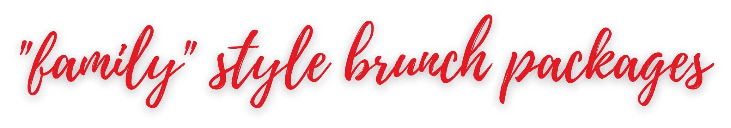
$23 per person. Available for parties of 15 Guests or more
Packages include fresh brewed regular and decaffeinated coffee, fresh squeezed orange juice, fresh fruits of the season, crispy yukon breakfast potatoes and choice of applewood smoked bacon or Italian sausage links.
Add gelato 3 per scoop.

'
choice of 2

SCRAMBLED EGGS
whipped mascarpone / chives

TRUFFLE SCRAMBLED EGGS
whipped cage free eggs / wild mushrooms / truffle oil

ADD 2

TIRAMISU FRENCH TOAST
espresso creme anglaise / fresh berries / maple syrup / marsala whipped mascarpone

LEMON RICOTTA PANCAKES
fresh berry compote / candied lemon / whipped cream / maple syrup / lemon glaze

SOUTHERN ITALIAN BISCUITS + GRAVY
italian sausage + calabrian chili gravy / buttermilk biscuits

NORTHERN ITALIAN STYLE EGGS BENEDICT
poached eggs / garlic toast / roasted tomatoes / arugula / prosciutto / fresh hollandaise

SHORT RIB HASH SCRAMBLE
crispy yukon potatoes / charred baby peppers / roasted onions / wild mushrooms /
cheddar + mozzarella/ eggs any style

ADD 3
TRUE BELGIAN WAFFLE
fresh berries / maple syrup / powdered sugar

FARMERS MARKET OMELET
whipped eggs / grilled corn / roasted peppers / onion / spinach / asparagus / goat cheese

PROSCIUTTO + SPINACH OMELET
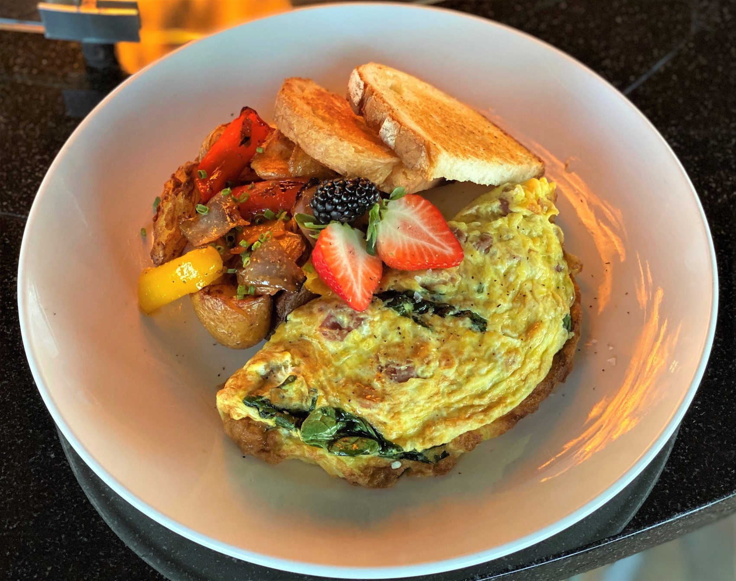
whipped eggs / shaved prosciutto / spinach / goat cheese

$23 per person. Available for parties of 15 Guests or more, up to 30 ppl ~ Dine in only
Packages include choice of salad, choice of 3 sandwiches.
Sandwiches served with fresh cut fries.

'
choice of 3

VAI’S PRIME BURGER
wood grilled / cheddar / herb garlic aioli / lettuce / onion / tomato / brioche bun ADD 3

ASIAGO CHICKEN FOCACCIA
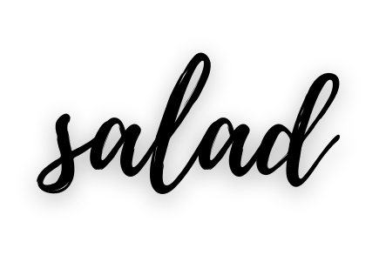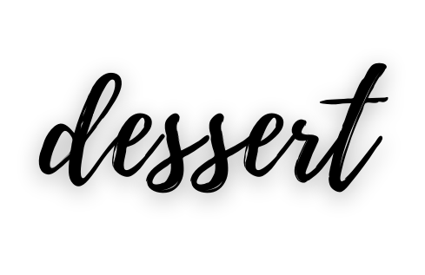asiago + panko crusted chicken breast / JOHNNY VAI’s hot pepper mix / arugula / sun dried tomato aioli / tomato focaccia ADD 3
choice of 1
HOUSE SALAD
mixed greens / fennel / candied pecans / gorgonzola / tomato / herb vinaigrette

WOOD GRILLED ROMAINE
grape tomato / crispy pancetta / gorgonzola / creamy asiago / fried leaks
choice of 1 / add 3
VANILLA GELATO CHOCOLATE GELATO
HOUSE MADE SUGAR COOKIES

WOOD GRILLED CHICKEN + AVOCADO MELT
house dried tomato/ applewood smoked bacon / provolone / arugula / parmesan lemon aioli

VEGGIE BURGER
our custom veggie blend / mozzarella / avocado / roasted tomatoes / arugula / charred jalape~no / green goddess dressing / toasted brioche bun

CHEESESTEAK
shaved New York strip / mushrooms / fontina / roasted tomatoes / arugula / caramelized onion / roasted garlic aioli / ciabatta

ADD 3

MEATBALL HERO
meatballs / mozzarella / marinara / ciabatta / arugula

CHICKEN PARMESAN SANDWICH
grilled chicken / mozzarella / marinara / ciabatta / arugula

NORTHERN ITALIAN GRINDER
prosciutto / spicy soppressata / pepperoni / fontina / mozzarella / herb vinaigrette / balsamic glaze JOHNNY VAI’s hot pepper mix / house focaccia

ADD 2

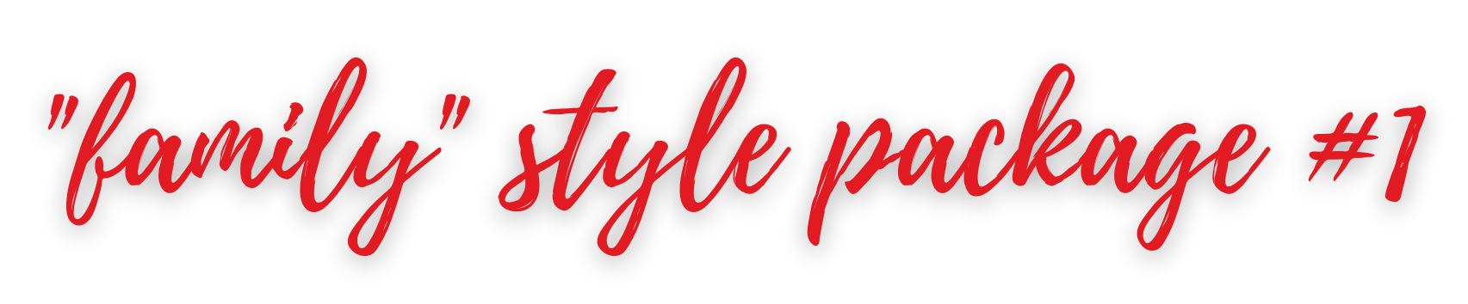
$23 per person / Available for LUNCH groups of 15 Guests or more - Dine in Only
Choice of 1 pasta, choice of 1 entree, choice of 1 salad and wood roasted vegetables served family style.
Served with house bruschetta & with parmesan pizza bread.
Plated meal available up to 30 people + $5pp.

'
select 1
select 1
CHICKEN MILAN
VODKA PASTA

heirloom tomato bruschetta / fresh mozzarella /
'
arugula + frisee / balsamic glaze

CHICKEN PARMESAN
herb + panko breaded / mozzarella / sugo / arugula + frisee ADD 1

'

ROASTED SALMON
wild mushrooms / charred carrots / spinach / arugula + frisee / lemon butter sauce

'

ADD 3

CHICKEN CARBONARA
garlic / shallots / pancetta / blistered tomatoes / peas / vino / cream / sage / pecorino / egg yolk / tagliatelle

ALMOND CRUSTED WHITEFISH
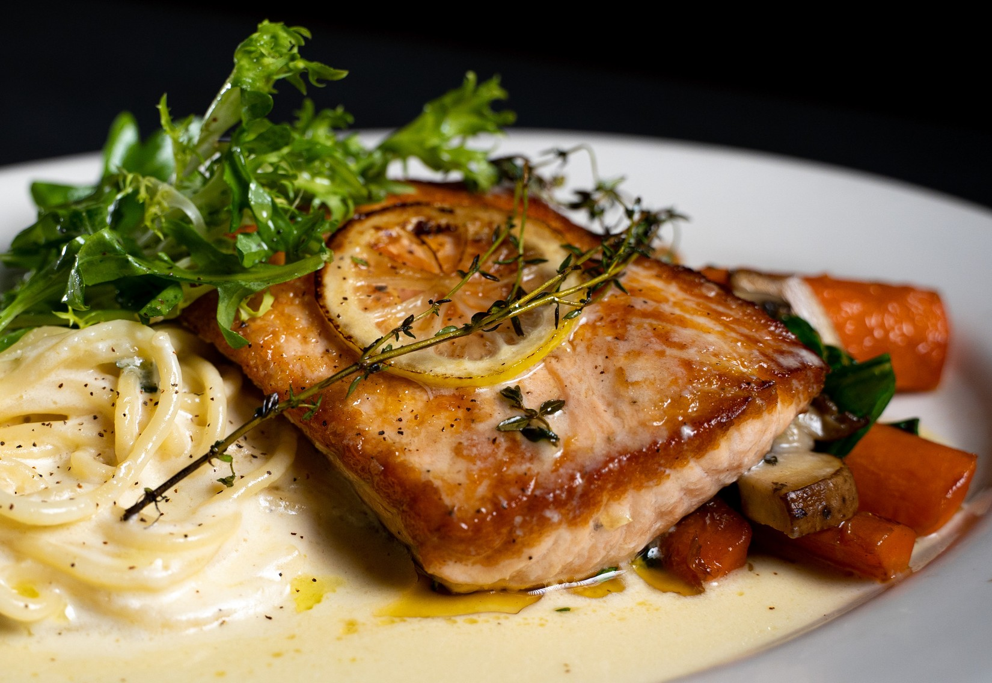roasted almond + panko crusted / arugula / lemon butter sauce
eight finger cavatelli / mascarpone tomato cream / garlic / crispy prosciutto / chili flake ADD 1

PASTA BOLOGNESE
fresh rigatoni / house made bolo sauce / pecorino ADD 1

FRESH CAVATELLI+ PARMESAN CREAM
garlic / basil / parmesan cream

BUCATINI + SUGO
garlic / basil / vino / sugo
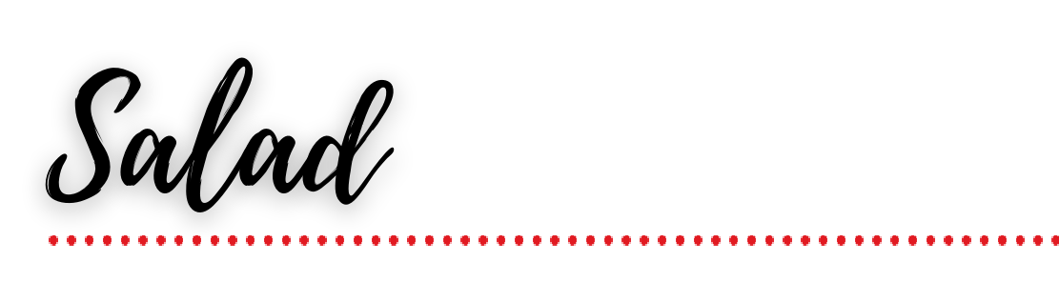
choice of 1
HOUSE SALAD
mixed greens / fennel / candied pecans / gorgonzola / tomato / herb vinaigrette

WOOD GRILLED ROMAINE
grape tomato / crispy pancetta / gorgonzola / creamy asiago / fried leaks

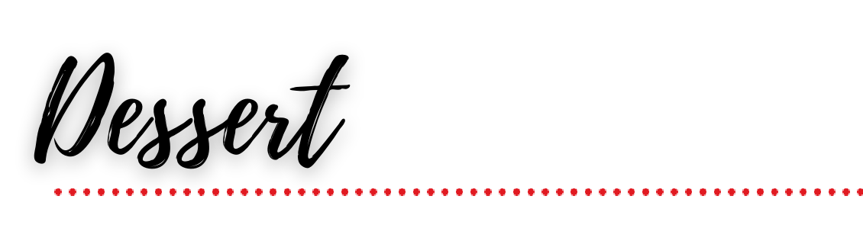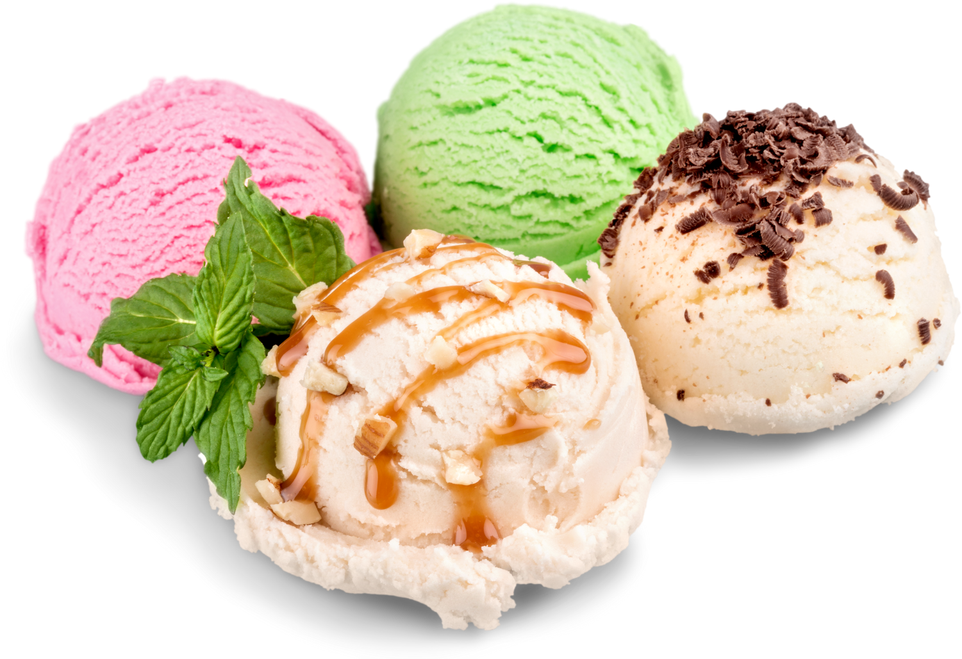
choice of 1 / add 3
SCOOP OF GELATO

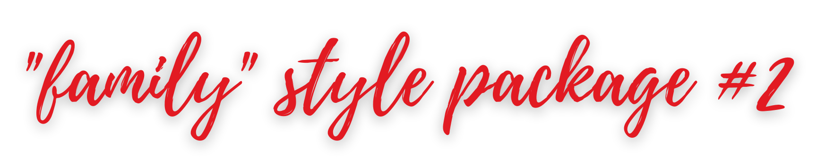
$28 per person / Available for parties of 15 Guests or more - Dine in Only
Choice of 1 main course, choice of salad, 2 sides. Main courses served with parmesan pizza bread. Plated meal available up to 30 people. add $5pp

'
select 1
choice of 2

VODKA PASTA
eight finger cavatelli / mascarpone tomato cream / garlic / crispy prosciutto / chili flake

PASTA BOLOGNESE
fresh rigatoni / house made bolo sauce / pecorino

CHICKEN CARBONARA
garlic / shallots / pancetta / blistered tomatoes / peas / vino / cream / sage / pecorino / egg yolk / tagliatelle

CHICKEN MILAN
heirloom tomato bruschetta / fresh mozzarella / arugula + frise' e / balsamic glaze

CHICKEN PARMESAN
herb + panko breaded / mozzarella / sugo / arugula + frise' e

ALMOND CRUSTED WHITEFISH
roasted almond + panko crusted / arugula / lemon butter sauce

ROASTED SALMON
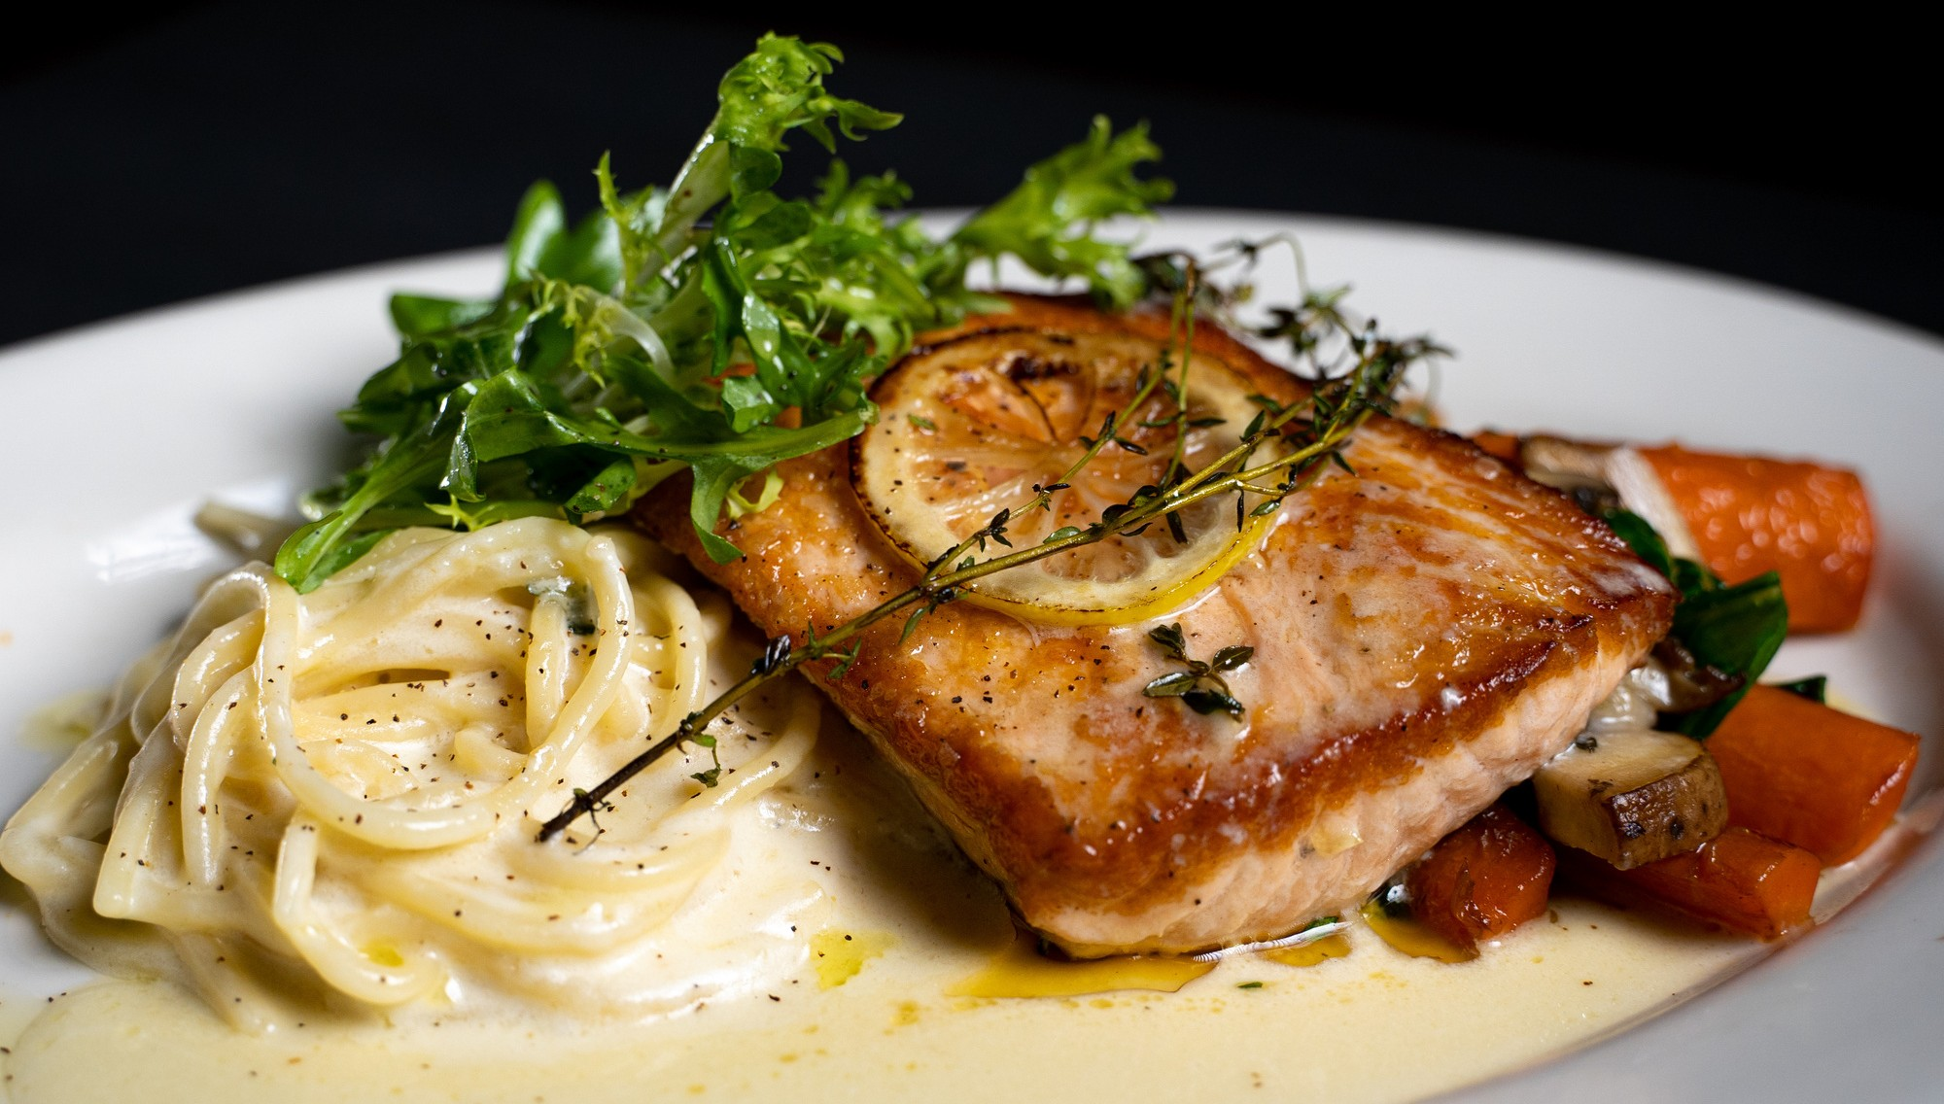
wild mushrooms / charred carrots / spinach / arugula + frise' e / lemon butter sauce

FRESH CAVATELLI + PARMESAN CREAM
garlic / basil / parmesan cream

FRESH RIGATONI+ SUGO
garlic / basil / vino / sugo

WOOD ROASTED VEGETABLES
seasonal vegetables / fresh herbs / sea salt / evoo

BROCCOLINI
wood grilled / garlic / lemon / sea salt / evoo

FRENCH BEANS + ITALIAN PEPPERS
garlic / shallots / evoo / sea salt

BRUSSELS SPROUTS
pecorino / bacon vinaigrette

PARMESAN STICKY POTATOES
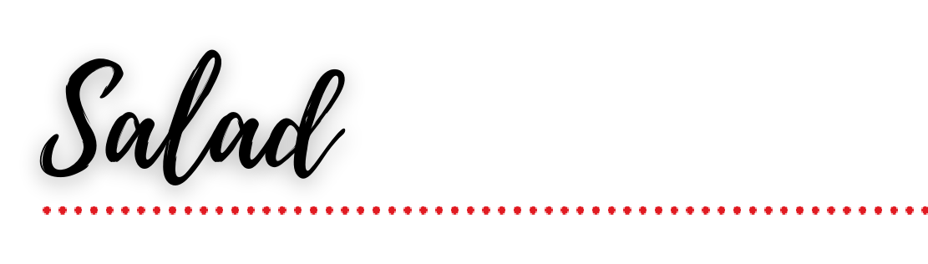
herb garlic butter / parmesan / truffle oil
choice of 1
HOUSE SALAD
mixed greens / fennel / candied pecans / gorgonzola / tomato / herb vinaigrette

WOOD GRILLED ROMAINE
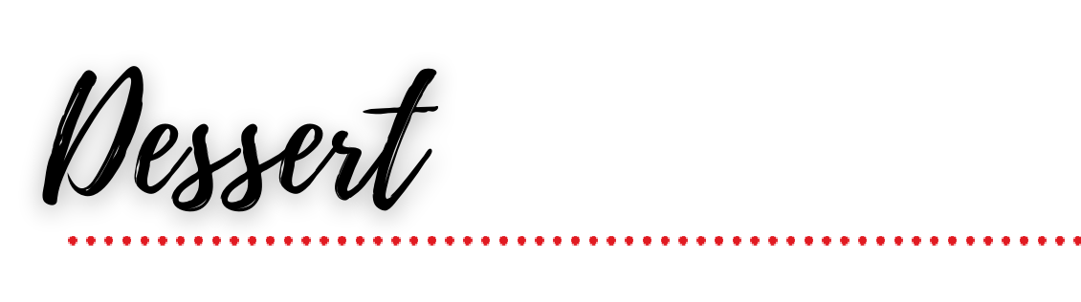
grape tomato / crispy pancetta / gorgonzola / creamy asiago / fried leaks

choice of 1 add 3

TIRAMISU add 3
GELATO add 3

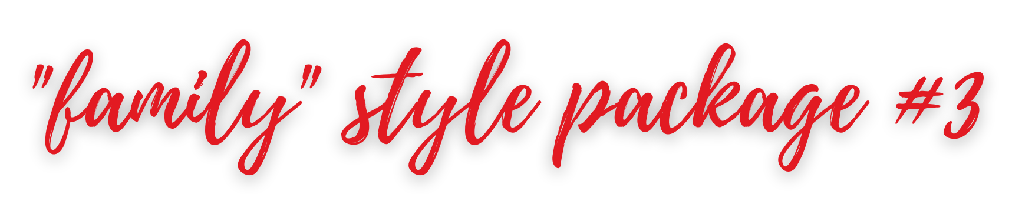
$34 per person / Available for parties of 15 Guests or more - Dine in Only
Choice of 1 main courses, choice of salad, 2 sides, parmesan pizza bread. Coffee, tea, fountain soda. Plated meal available up to 30 people. add $5pp

'
select 1
choice of 2
SHRIMP + SAUSAGE CAVATELLI
SPAGHETTI + PARMESAN CREAM

roasted peppers / spinach / garlic / shallot / vino /
mascarpone

SPICY CHICKEN TORTELLACCI ~
tomatoes / broccolini / garlic / jalapeno / spinach /
basil / lemon / parmesan cream

CHICKEN PICCATA
wild mushrooms / grilled artichokes / lemon caper butter sauce

CHICKEN MILAN
heirloom tom'ato bruschetta / fresh mozzarella / arugula + frisee / balsamic glaze

ORGANIC BRICK GRILLED CHICKEN
boneless ½ chicken / lemon + oregano natural pan sauce

FILET MEDALLIONS
garlic /shallots / thyme / peppercorn veal demi sauce

ADD 5
ROASTED SALMON
wild mushroo'ms / charred carrots / spinach / arugula + frisee / lemon butter sauce

WOOD GRILLED NEW YORK STRIP
Italian salsa verde

ADD 4
LOBSTER + SHRIMP RIGATONI
garlic / basil / parmesan cream

BUCATINI + SUGO
garlic / basil / vino / sugo

WOOD ROASTED VEGETABLES
seasonal vegetables / fresh herbs / sea salt / evoo

BROCCOLINI
wood grilled / garlic / lemon / sea salt / evoo

CACIO E PEPE POLENTA
parmesan / cream / black pepper / hot pepper mix / evoo

BRUSSELS SPROUTS
pecorino / bacon vinaigrette

PARMESAN STICKY POTATOES
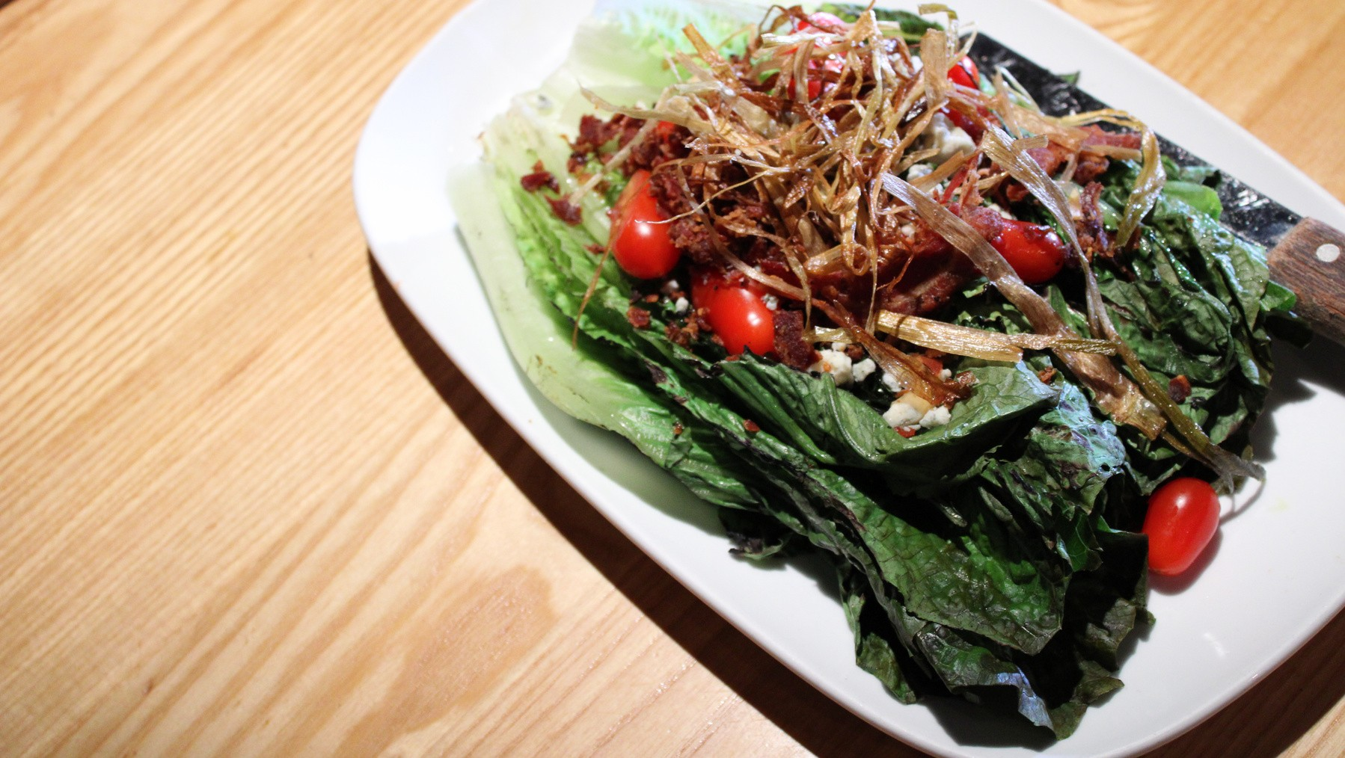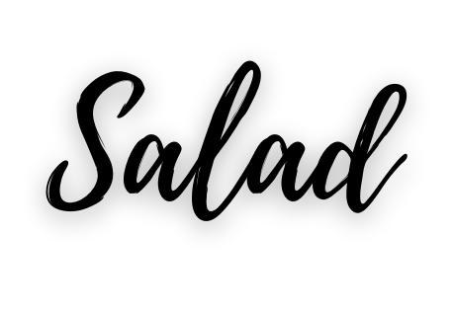herb garlic butter / parmesan / truffle oil
choice of 1
HOUSE SALAD

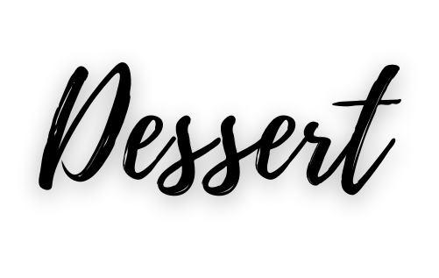
garlic /tomato / spinach / vino / lemon / parmesan cream
ADD 9

choice of 1 family style
(*for every 3 people)

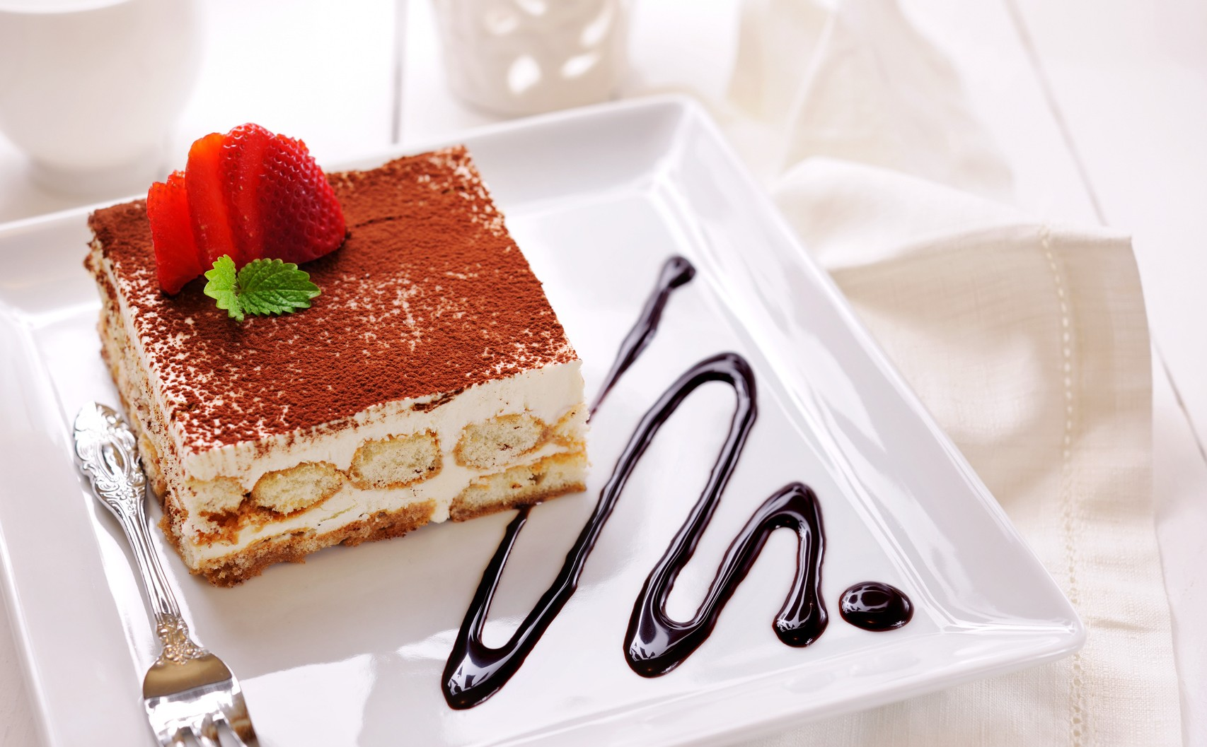
*TIRAMISU
*SANDY'S WHITE WINE CAKE
*FLOURLESS CHOCOLATE CAKE
*MINI ASSORTED DESSERTS PLATTER -
white chocolate raspberry cheesecake / white wine cake / berries + cream flour- less chocolate cake / tiramisu /
ADD - 3 PP
mixed greens / fennel / candied pecans / gorgonzola / tomato / herb vinaigrette

ITALIAN CHOPPED SALAD
artichoke hearts / charred mini peppers / red onion / baby tomatoes / pepperoncini / soppressata picante / avocado / gorgonzola / lemon vinaigrette

WOOD GRILLED ROMAINE
grape tomato / crispy pancetta / gorgonzola / creamy asiago / fried leaks

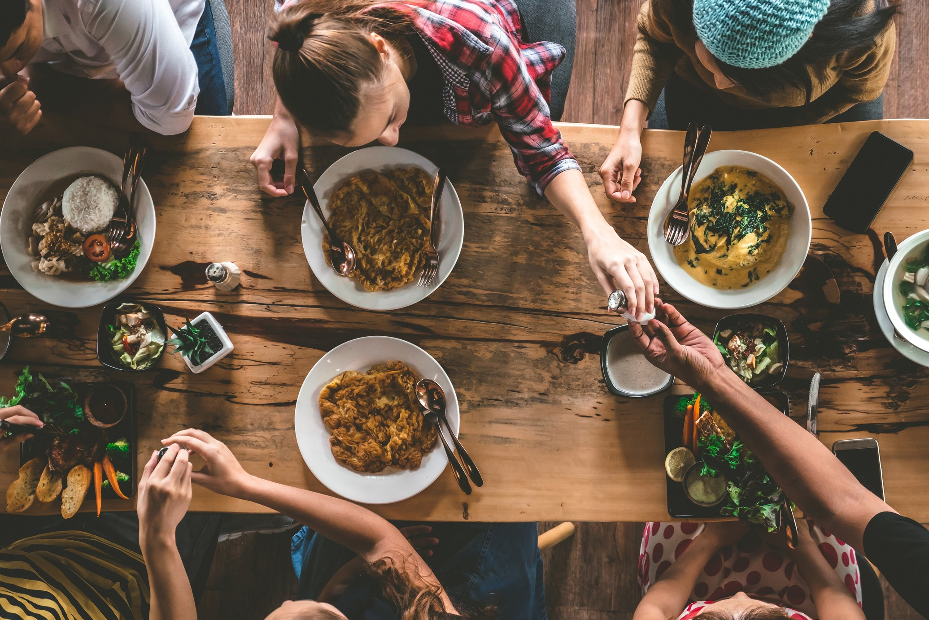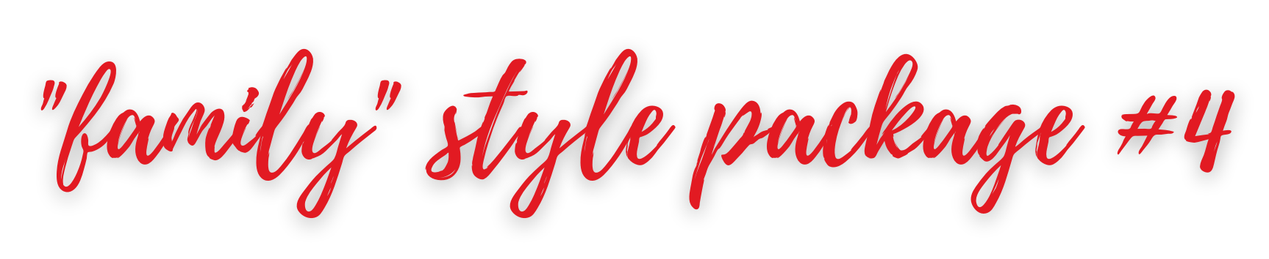$39 per person / Available for parties of 15 Guests or more
- Dine in Only
Choice of 1 entree
course, choice of salad, 2 sides, dessert, coffee, tea, fountain soda.
Parmesan pizza bread. Plated meal available up to 30 people.
add $5pp

choice of 2

'

select 1

SHRIMP + SAUSAGE CAVATELLI
roasted peppers / spinach / garlic / shallot / vino / mascarpone

SHORT RIB RIGATONI
blistered / tomatoes / horseradish / arugula / parmesan cream / pecorino

CHICKEN MADEIRA
wild mushrooms /garlic / shallots / fresh mozzarella / madeira veal sauce

CHICKEN THIGH SALTIMBOCCA
crispy prosciutto / sage / lemon chicken pan sauce

HORERADISH CRUSTED FILET MEDALLIONS
peppercorn veal demi sauce

ROASTED BRANZINO
wild mushrooms / roasted cauliflower / charred peppers / lemon caper butter sauce

CHILEAN SEABASS
grilled corn + asparagus relish / pesto butter sauce

ADD 10
KONA RUBBED PRIME RIBEYE
12 oz. LHA prime / kona coffee crusted / calabrian chili butter

ADD 7
LOBSTER + SHRIMP RIGATONI
garlic /tomato / spinach / vino / lemon / parmesan cream

ADD 5
SPAGHETTI + PARMESAN CREAM
garlic / basil / parmesan cream

BUCATINI + SUGO
garlic / basil / vino / sugo

WOOD ROASTED VEGETABLES
seasonal vegetables / fresh herbs / sea salt / evoo

VODKA PASTA
eight finger cavatelli / mascarpone tomato cream / garlic / crispy prosciutto / chili flake

FRENCH BEANS + ITALIAN PEPPERS
garlic / shallots / evoo / sea salt

BRUSSELS SPROUTS
pecorino / bacon vinaigrette

PARMESAN STICKY POTATOES
herb garlic butter / parmesan / truffle oil
choice of 1
KALE & QUINOA

fuji apples / sunflower seeds / dates / manchego / lemon vinaigrette

ROASTED HEIRLOOM BEETS
baby greens / shaved fennel / pistachio / goat cheese / orange / lemon vinaigrette

ITALIAN CHOPPED SALAD
artichoke hearts / charred mini peppers / red onion / baby tomatoes / pepperoncini / soppressata picante / avocado / gorgonzola / lemon vinaigrette

choice of 1 family style
(*for every 3 people)

*TIRAMISU
*SANDY'S WHITE WINE CAKE
*FLOURLESS CHOCOLATE CAKE
MINI ASSORTED DESSERTS PLATER -
white chocolate raspberry cheesecake /
key lime pie / white wine cake / berries + cream flourless chocolate cake / ADD 3 PP

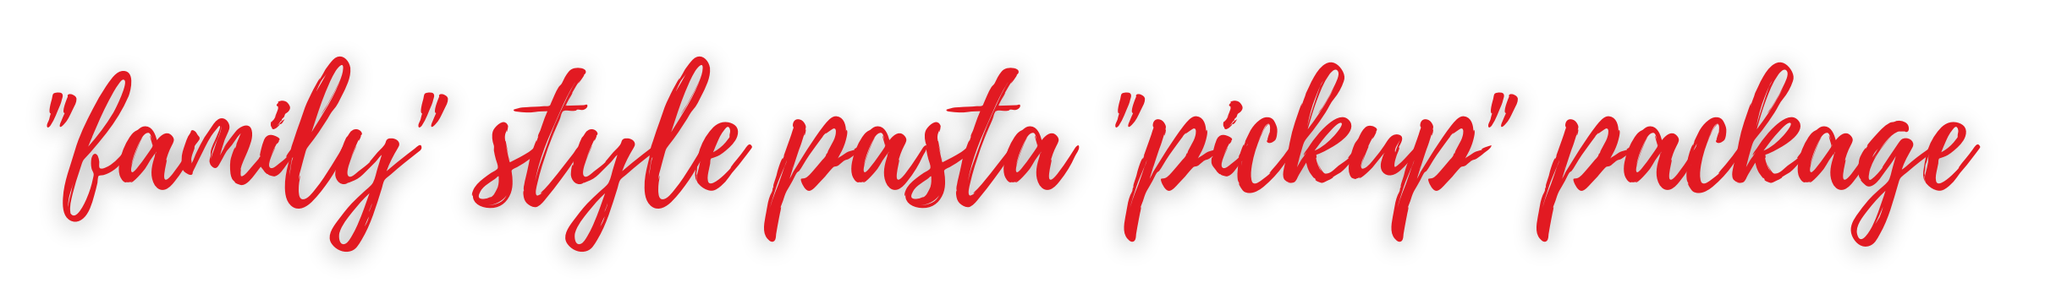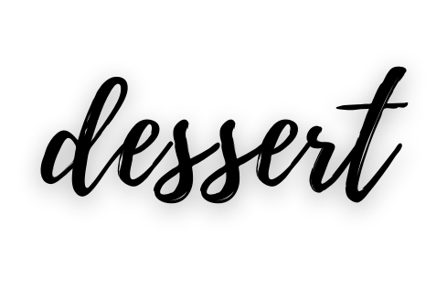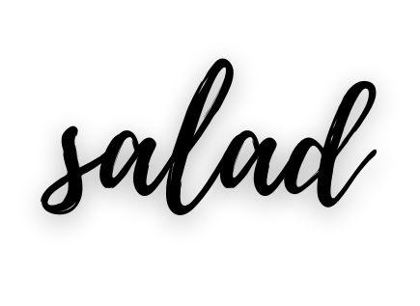Serves 4 - 8 people ~ off premise only
Choice of 1 main course, choice of salad and, dessert.
$50 Delivery option available / will deliver 3 mile radius only
$250 minimum for delivery order

choice of 1

VODKA PASTA 69 half / 120 full
eight finger cavatelli / mascarpone tomato cream / garlic / crispy prosciutto / chili flake

PASTA BOLOGNESE 69 half / 120 full
fresh rigatoni / house made bolo sauce / pecorino

WILD MUSHROOM SACCHETTI 84 half / 150 full
wild mushrooms / garlic / chili flakes / vino / fresh herbs / pecorino / cream / truffle oil

SPICY CHICKEN TORTELLACCI 84 half / 150 full
tomatoes / broccolini / garlic / jalapeño / spinach / basil / lemon parmesan cream

SHRIMP + SAUSAGE CAVATELLI 84 half / 150 full
italian sausage / shrimp / roasted peppers / spinach / garlic / shallot / vino / mascarpone

HOUSE SALAD
mixed greens / fennel / candied pecans / gorgonzola / tomato / herb vinaigrette

TIRAMISU
caramel sauce / whipped cream / cocoa

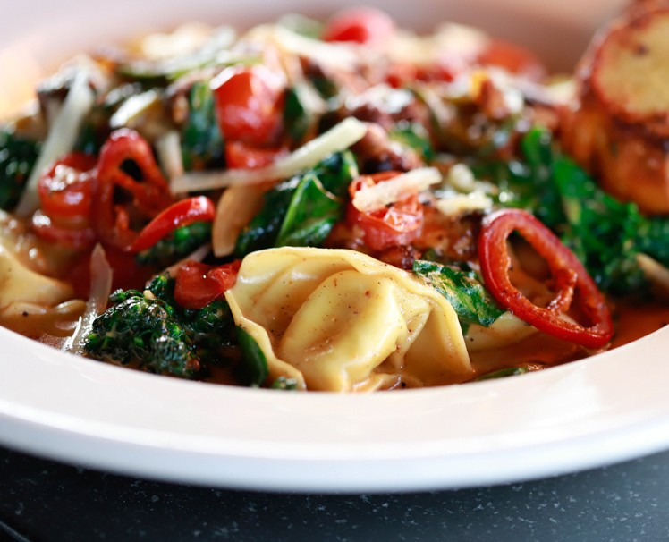
*heating racks / sterno & serving utensils / $15 per set*

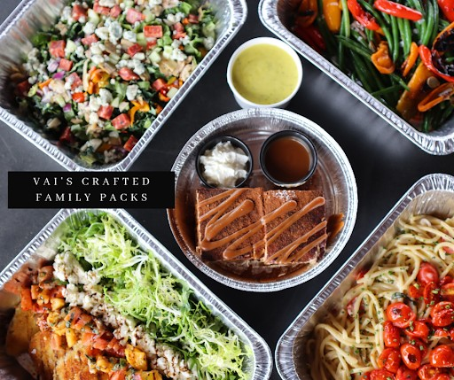

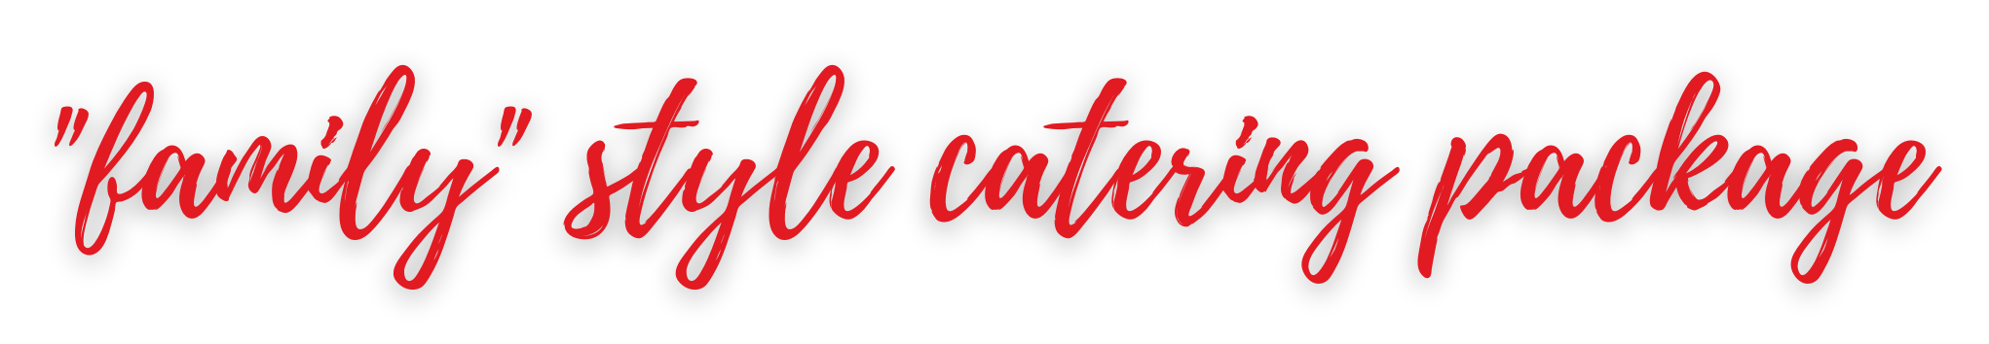

Serves 4 people ~ Off premise only
Choice of 1 main course, choice of salad,
2 sides and dessert. Delivery Options available

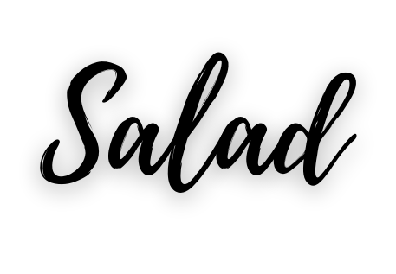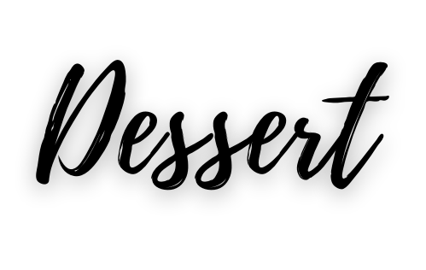'
choice of 1
HOUSE SALAD
mixed greens / fennel / candied pecans / gorgonzola / tomato / herb vinaigrette
ITALIAN CHOPPED SALAD
artichoke hearts / charred mini peppers / red onion / baby tomatoes / pepperoncini / soppressata picante / avocado / gorgonzola / lemon vinaigrette
TIRAMISU
caramel sauce / whipped cream / cocoa

choice of 1

CHICKEN MILAN 89

(6 - 3 oz. chicken breasts)
pan fried / herb + panko crusted chicken breast / heirloom tomatoes / fresh mozzarella / garlic / basil / arugula + frisee / balsamic glaze / lemon / evoo /

'
sea salt

ROASTED SALMON 99

(6 - 3 oz. salmon filets) '
wild mushrooms / charred carrots / arugula + frisee / vino / thyme / spinach / lemon

HORSERADISH CRUSTED FILET MEDALLIONS 125

(8 - 3 oz. filet medallions)
peppercorn demi sauce

PRIME RIB 250 - SERVES 6-8 P
5lb. av. / USDA prime
boneless prime rib roast / slow roasted / au jus / horseradish cream
choice of 2

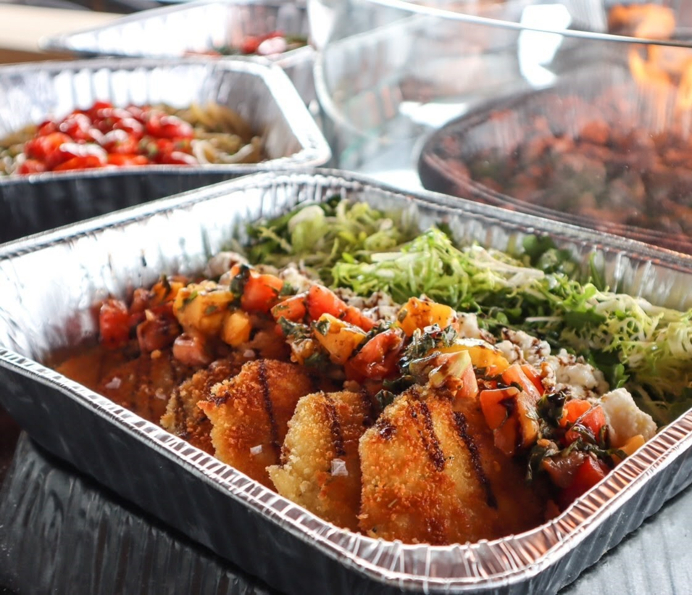
FRESH RIGATONI + HOUSE SUGO
garlic / basil / vino / blistered tomatoes / sugo

FRESH RIGATONI + PARM CREAM
garlic / basil / vino / cream / blistered tomatoes / charred baby peppers / parmesan

WOOD ROASTED VEGETABLES
seasonal vegetables / fresh herbs / sea salt / evoo

VODKA PASTA
eight finger cavatelli / mascarpone tomato cream / garlic / crispy prosciutto / chili flake

FRENCH BEANS + ITALIAN PEPPERS
garlic / shallots / evoo / sea salt

BRUSSELS SPROUTS
pecorino / bacon vinaigrette

PARMESAN STICKY POTATOES
herb garlic butter / parmesan / truffle oil

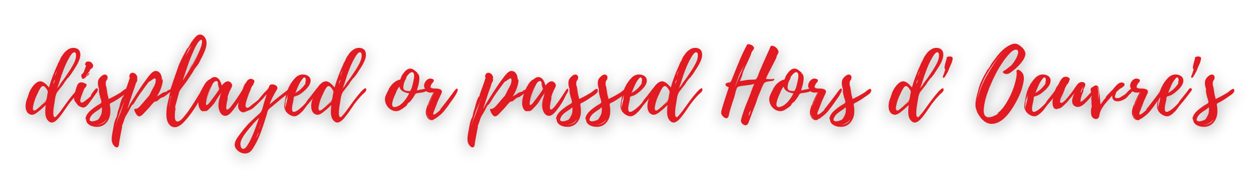

priced per each / 24 piece minimum

VAI’S PRIME BURGER SLIDERS 4.50
cheddar / herb + garlic aioli / lettuce / tomato / mini brioche bun

CHICKEN MILAN SLIDERS 3.50
heirloom tomato bruschetta / fresh mozzarella / mixed greens / pretzel bun

PANCETTA WRAPPED SHRIMP SHOOTER 4.25 roasted
garlic lemon butter

COLORADO LAMB RIBS 4.50
wood grilled / mint + rosemary lamb jus

COCONUT SHRIMP 3.75
sweet calabrese chili dipping sauce

BACON WRAPPED JALAPENOS 2.75
wood grilled, pimento + white cheddar stuffed

ASIAGO + GRILLED ARTICHOKE CROSTINI 3.25 ciabatta
crostini / grilled artichokes / asiago al forno

MEATBALL STUFFED ARANCINI 3.25
house meatball stuffed risotto cake / sugo / parmesan / crispy onions

ARANCINI AL FORNO 2.75
risotto cake / fontina / mozzarella / fontina / roasted garlic / sugo

MINI PRIME BEEF WELLINGTON 5.50
black truffle bearnaise

OCTOPUS SPEDINI 3.75
mediterranean marinated / calabrian chili aioli

BONE-IN FILET “CHOPS” 6
2.5 oz. LHA reserve / horseradish cream

PANCETTA WRAPPED SCALLOPS 7
lemon basil butter sauce / micro

FRIED OLIVES 1.75
stuffed with Italian sausage and gouda

JUMBO LUMP CRAB + SPINACH STUFFED MUSHROOMS 4
lemon + old bay butter sauce

STUFFED BANANA PEPPERS 2.75
Italian sausage / mozzarella / asiago / sugo

PROSCIUTTO SPIEDINI 2.75
prosciutto wrapped fontina / wood grilled / hot honey / balsamic syrup

WOOD ROASTED BONE MARROW 9
wild mushroom + truffle crusted / fig jam / grilled ciabatta

WOOD ROASTED OYSTER CASINO 4.50
casino butter / prosciutto / gremolata breadcrumbs

OYSTER ROCKEFELLER 4.50
creamed spinach / pancetta / bearnaise / pecorino

WOOD GRILLED CALABRIAN SHRIMP 3.75
lemon /garlic / salsa verde aioli

TUSCAN FILET SLIDERS 6
sundried tomato aioli / bacon + onion jam / arugula / mini ciabatta buns

priced per each / 24 piece minimum
serves 10-12

STEAK TARTE SPOONS 3.50
black truffle aioli / reggiano parmesan / micro

CRISPY PROSCIUTTO DEVILED EGGS 2.75
truffle oil / pecorino / chives

MINI LOBSTER ROLLS 11
butter poached knuckle + claw meat / lemon aioli / baby gem / mini brioche

HEIRLOOM TOMATO BRUSCHETTA 2.75
grilled ciabatta / parmesan / balsamic glaze / evoo

SHRIMP COCKTAIL SHOOTERS 4.50
atomic cocktail sauce

AHI TUNA TARTARE SPOONS 4
calabrian chilies / lemon zest / evoo / sea salt

RICOTTA + FIG JAM BRUSCHETTA 2.50
whipped ricotta / fig jam / pistachios / honey / balsamic syrup

CAPRESE SPEDINI 2.75
baby tomatoes / basil / fresh mozzarella / evoo / balsamic syrup

PROSCIUTTO E MELONE 2.75
shaved prosciutto / fresh cantaloupe

OYSTER SHOOTERS 4
seasonal oysters / bloody mary / horseradish

ADD VODKA 3
LOCAL + IMPORTED CHEESES 75
fig jam / marcona almonds / honeycomb / fresh berries / grilled grapes

WOOD GRILLED SEASONAL VEGETABLES 45
market vegetables / green goddess dipping sauce

PRIME DRY AGED FILET CARPACCIO 65
black truffle aioli / fried capers / micro arugula / pecorino / sea salt / grilled ciabatta

FRESH FRUITS OF THE SEASON 65
mixed berry yogurt dipping sauce

CHEF’S BOARD 85
soppressata picante / prosciutto / coppa / fig jam / marcona almonds / marinated olives / pecorino / gorgonzola / giardiniera / grilled artichokes / grilled ciabatta

MINI ASSORTED DESSERTS ~ feeds 15 people ~ 75
white chocolate raspberry cheesecake / white wine cake / tiramisu / flourless chocolate cake

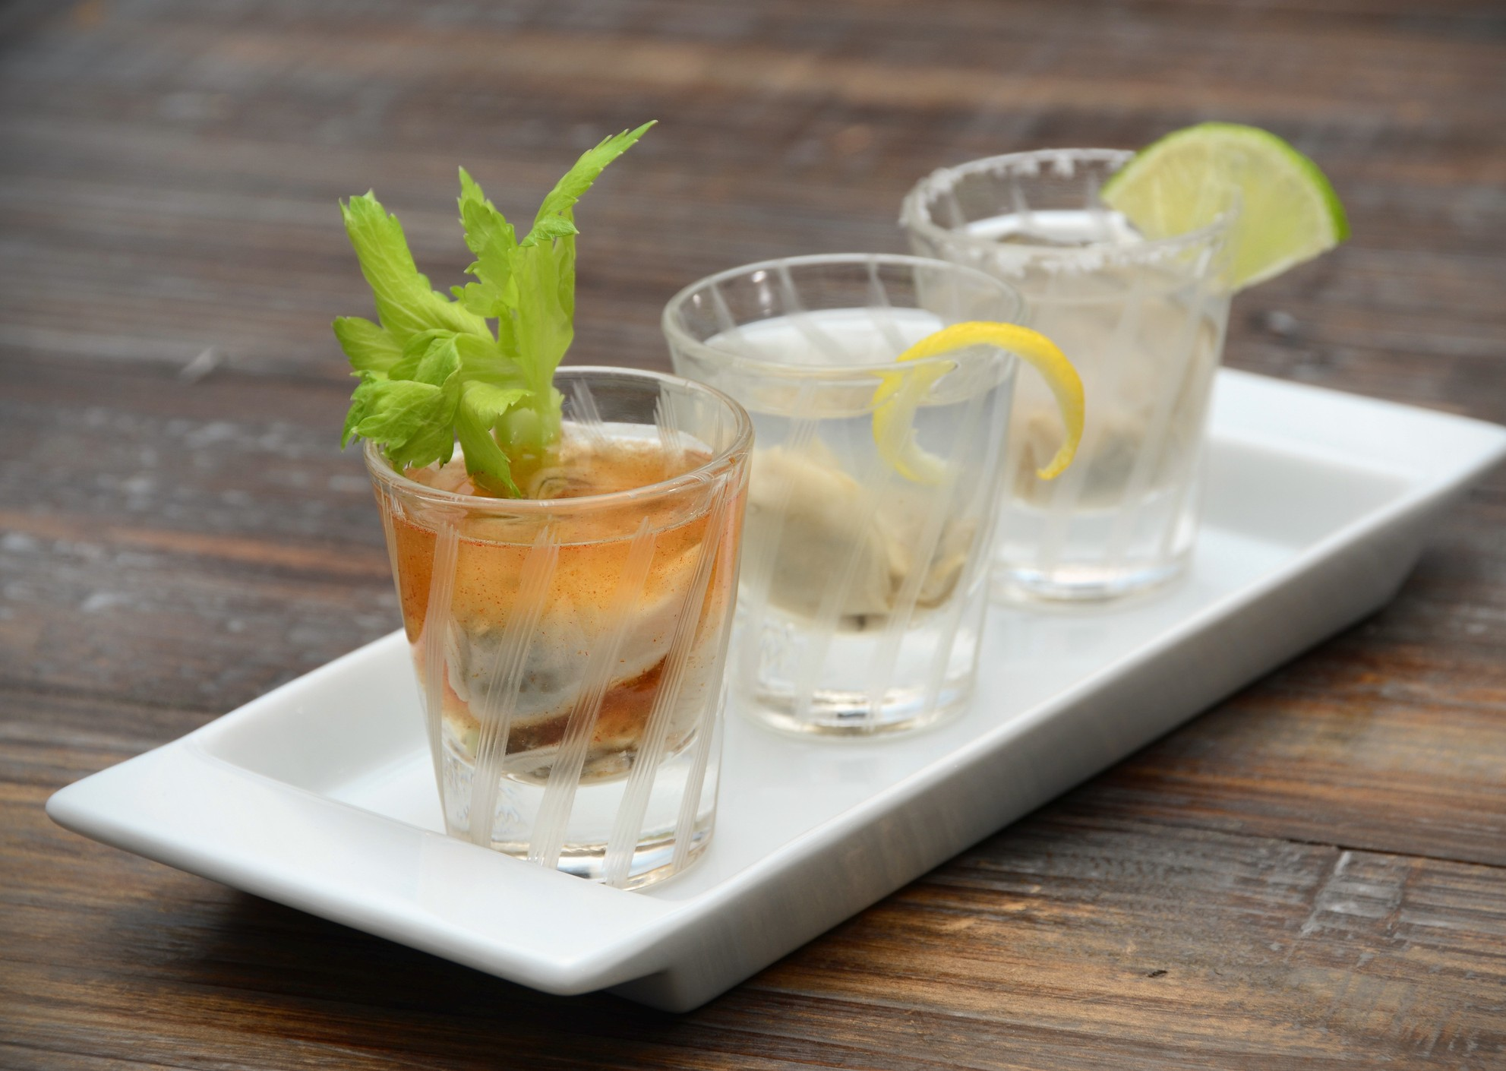LIFE
OVER PLATES

Packages are priced per person. Charges apply to all guests 21 years of age and older in attendance at the event. VAI's requires all guests consuming alcohol to provide valid identification. Price does not include additional beverages, tax, or service fee. Shots are not available as part of the beverage packages. Upgraded wine selections are available for an additional fee.

WINE & BEER PREMIUM SPIRITS SUPER - PREMIUM SPIRITS

Includes VAI's house selections of Italian red & white wines and domestic & imported beers

Two Hours - $25 Three Hours - $29
Includes VAI's house selections of Italian red & white wines and spirits & mixers

Two Hours - $30 Three Hours - $35
Includes VAI's house selections of Italian red & white wines and domestic & imported beers, spirits and mixers

Two Hours - $35 Three Hours - $40

NON - PACKAGE BAR OPTIONS

HOST BAR LIMITED HOST BAR CASH BAR

A host bar allows your guests to order from the full array of wine, beer, and spirits available at VAI's. The final bar tab is based on consumption and is paid by the event host at the conclusion of the function.
A limited host bar allows your guests to order from a specific selection of wine, beer, and spirits that you have selected prior to the start of the event. The final bar tab is based on consumption and is paid by the event host at the conclusion of the function.
A cash bar requires guests to pay for their own alcoholic beverages on consumption. Fountain drinks, brewed iced tea, hot tea, and regular & decaf American coffee are free of charge and included in all lunch and dinner menu packages.

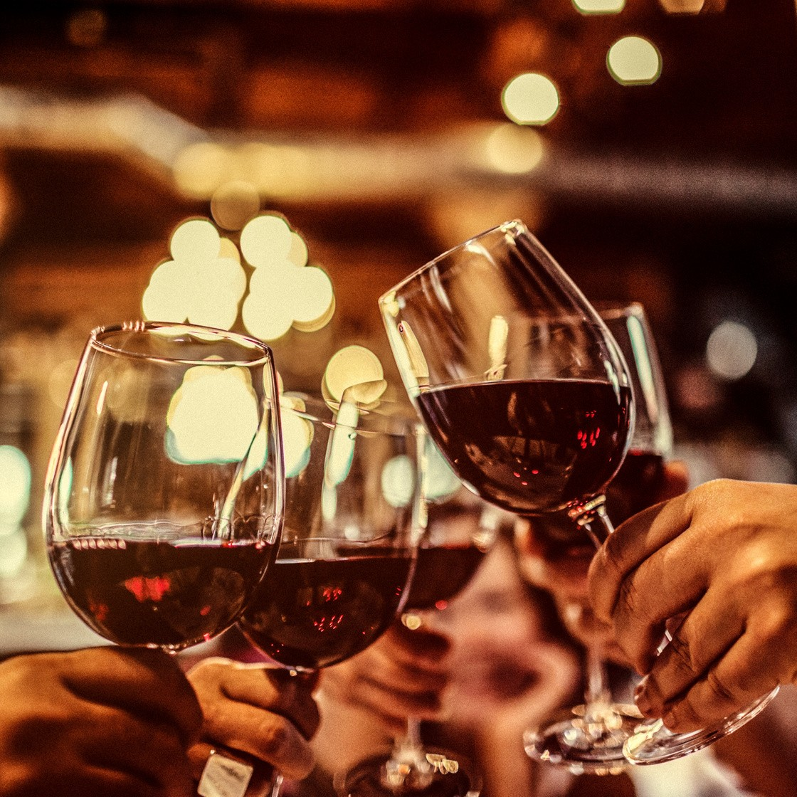VAI's reserves the right to discontinue beverage service to event attendees at any point in time if over-consumption of alcohol is suspected. Determination is at the sole discretion of the restaurant operator and no credit for purchase will be issued.
UPGRADES & CUSTOMIZATIONS
Talk with your events sales manager about training your special event into a one of-a-kind experience.
PROSECCO TOAST BLOODY MARY SERVICE
HOUSEMADE LIMONCELLO & NOCINO SERVICE
MIMOSA'S $5 / BLOODY MARY'S $6/ PEACH BELINNI'S $6 PER DRINK
NON ALCOHOLIC BEVERAGE
prices will vary
UNLIMITED COFFEE / TEA / FOUNTAIN SODA 3.50 PP

